Discover
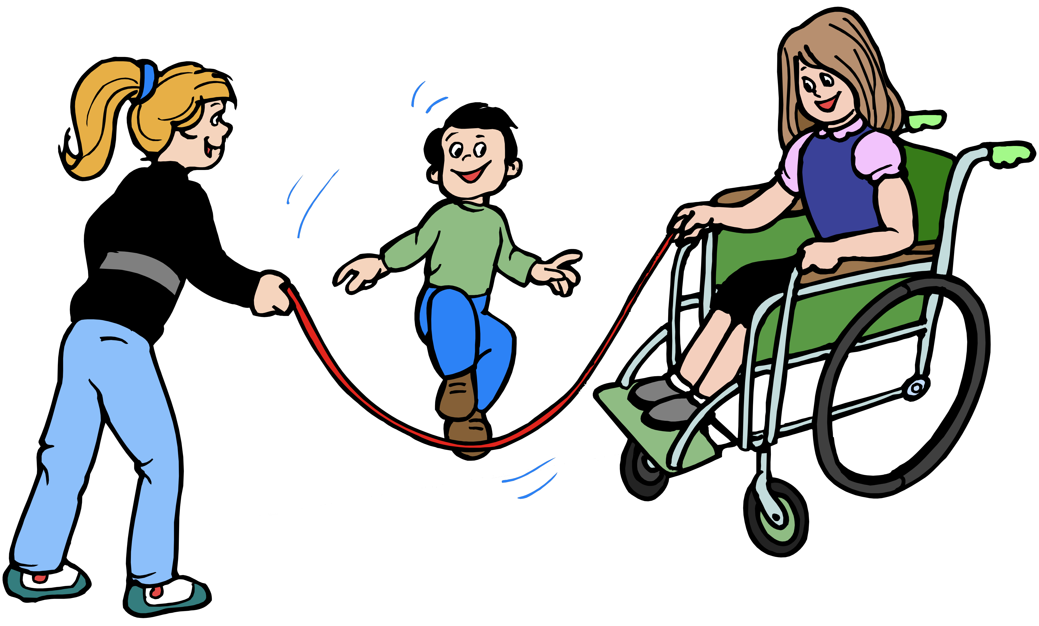 Adaptations for
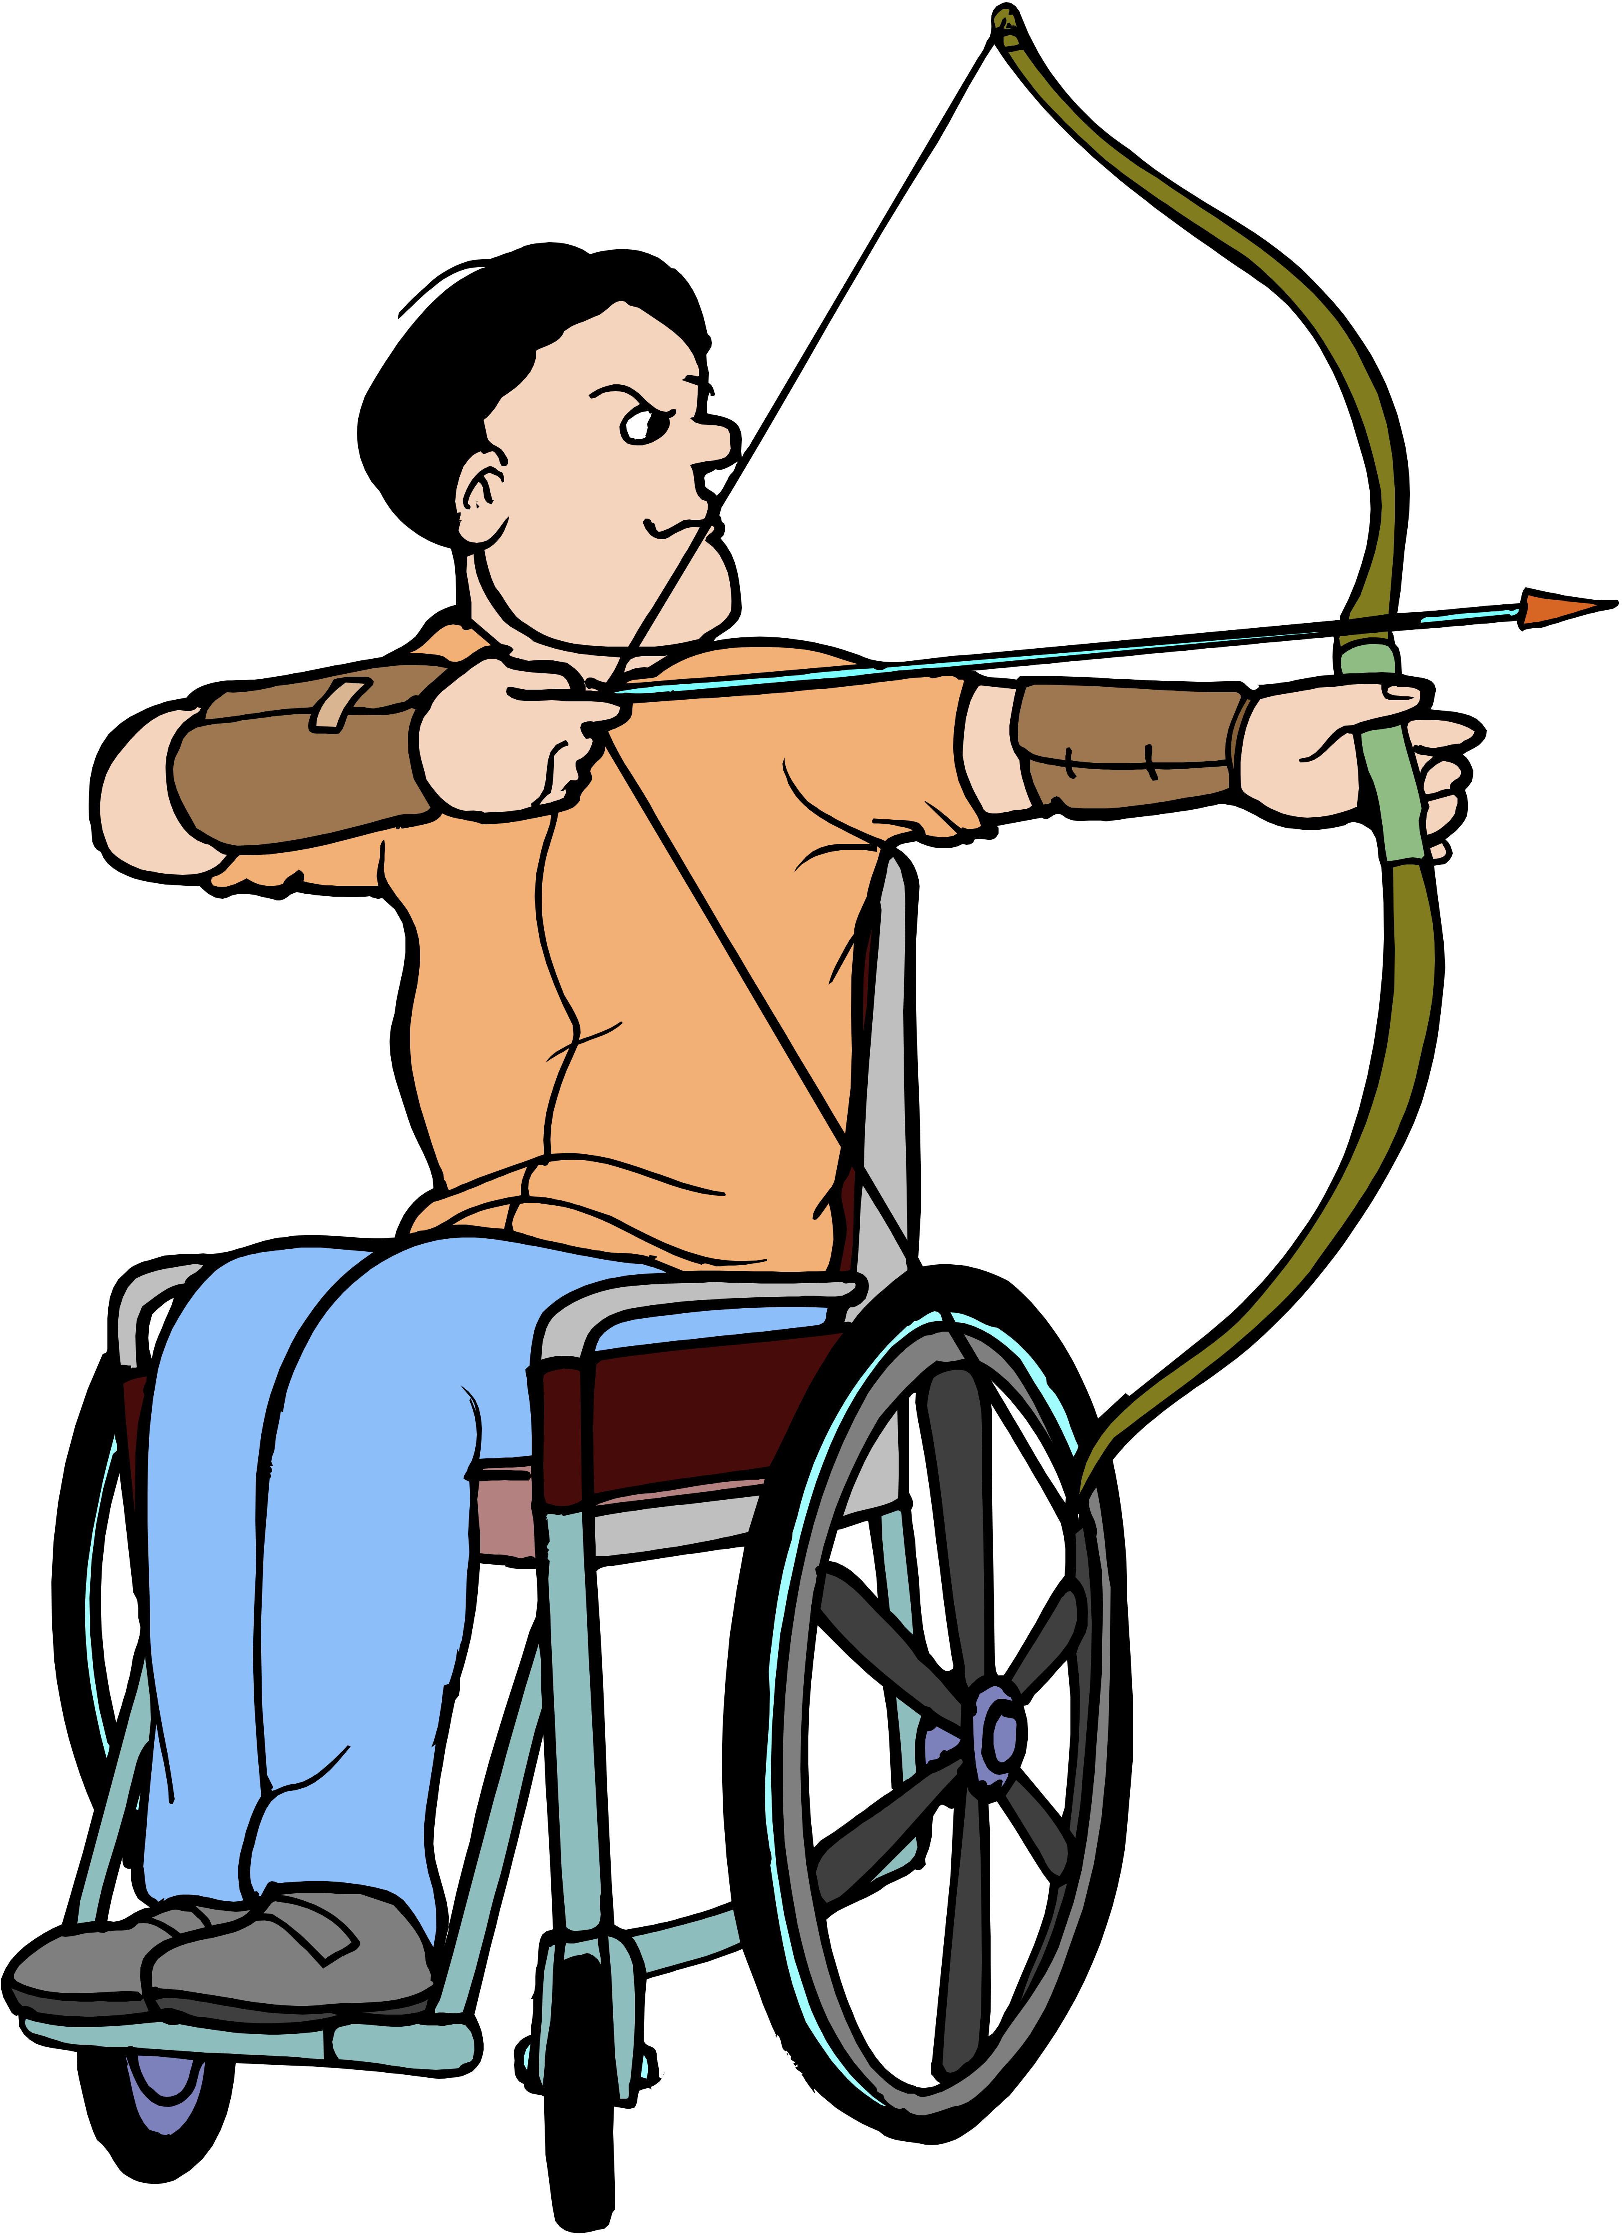Physical
Education

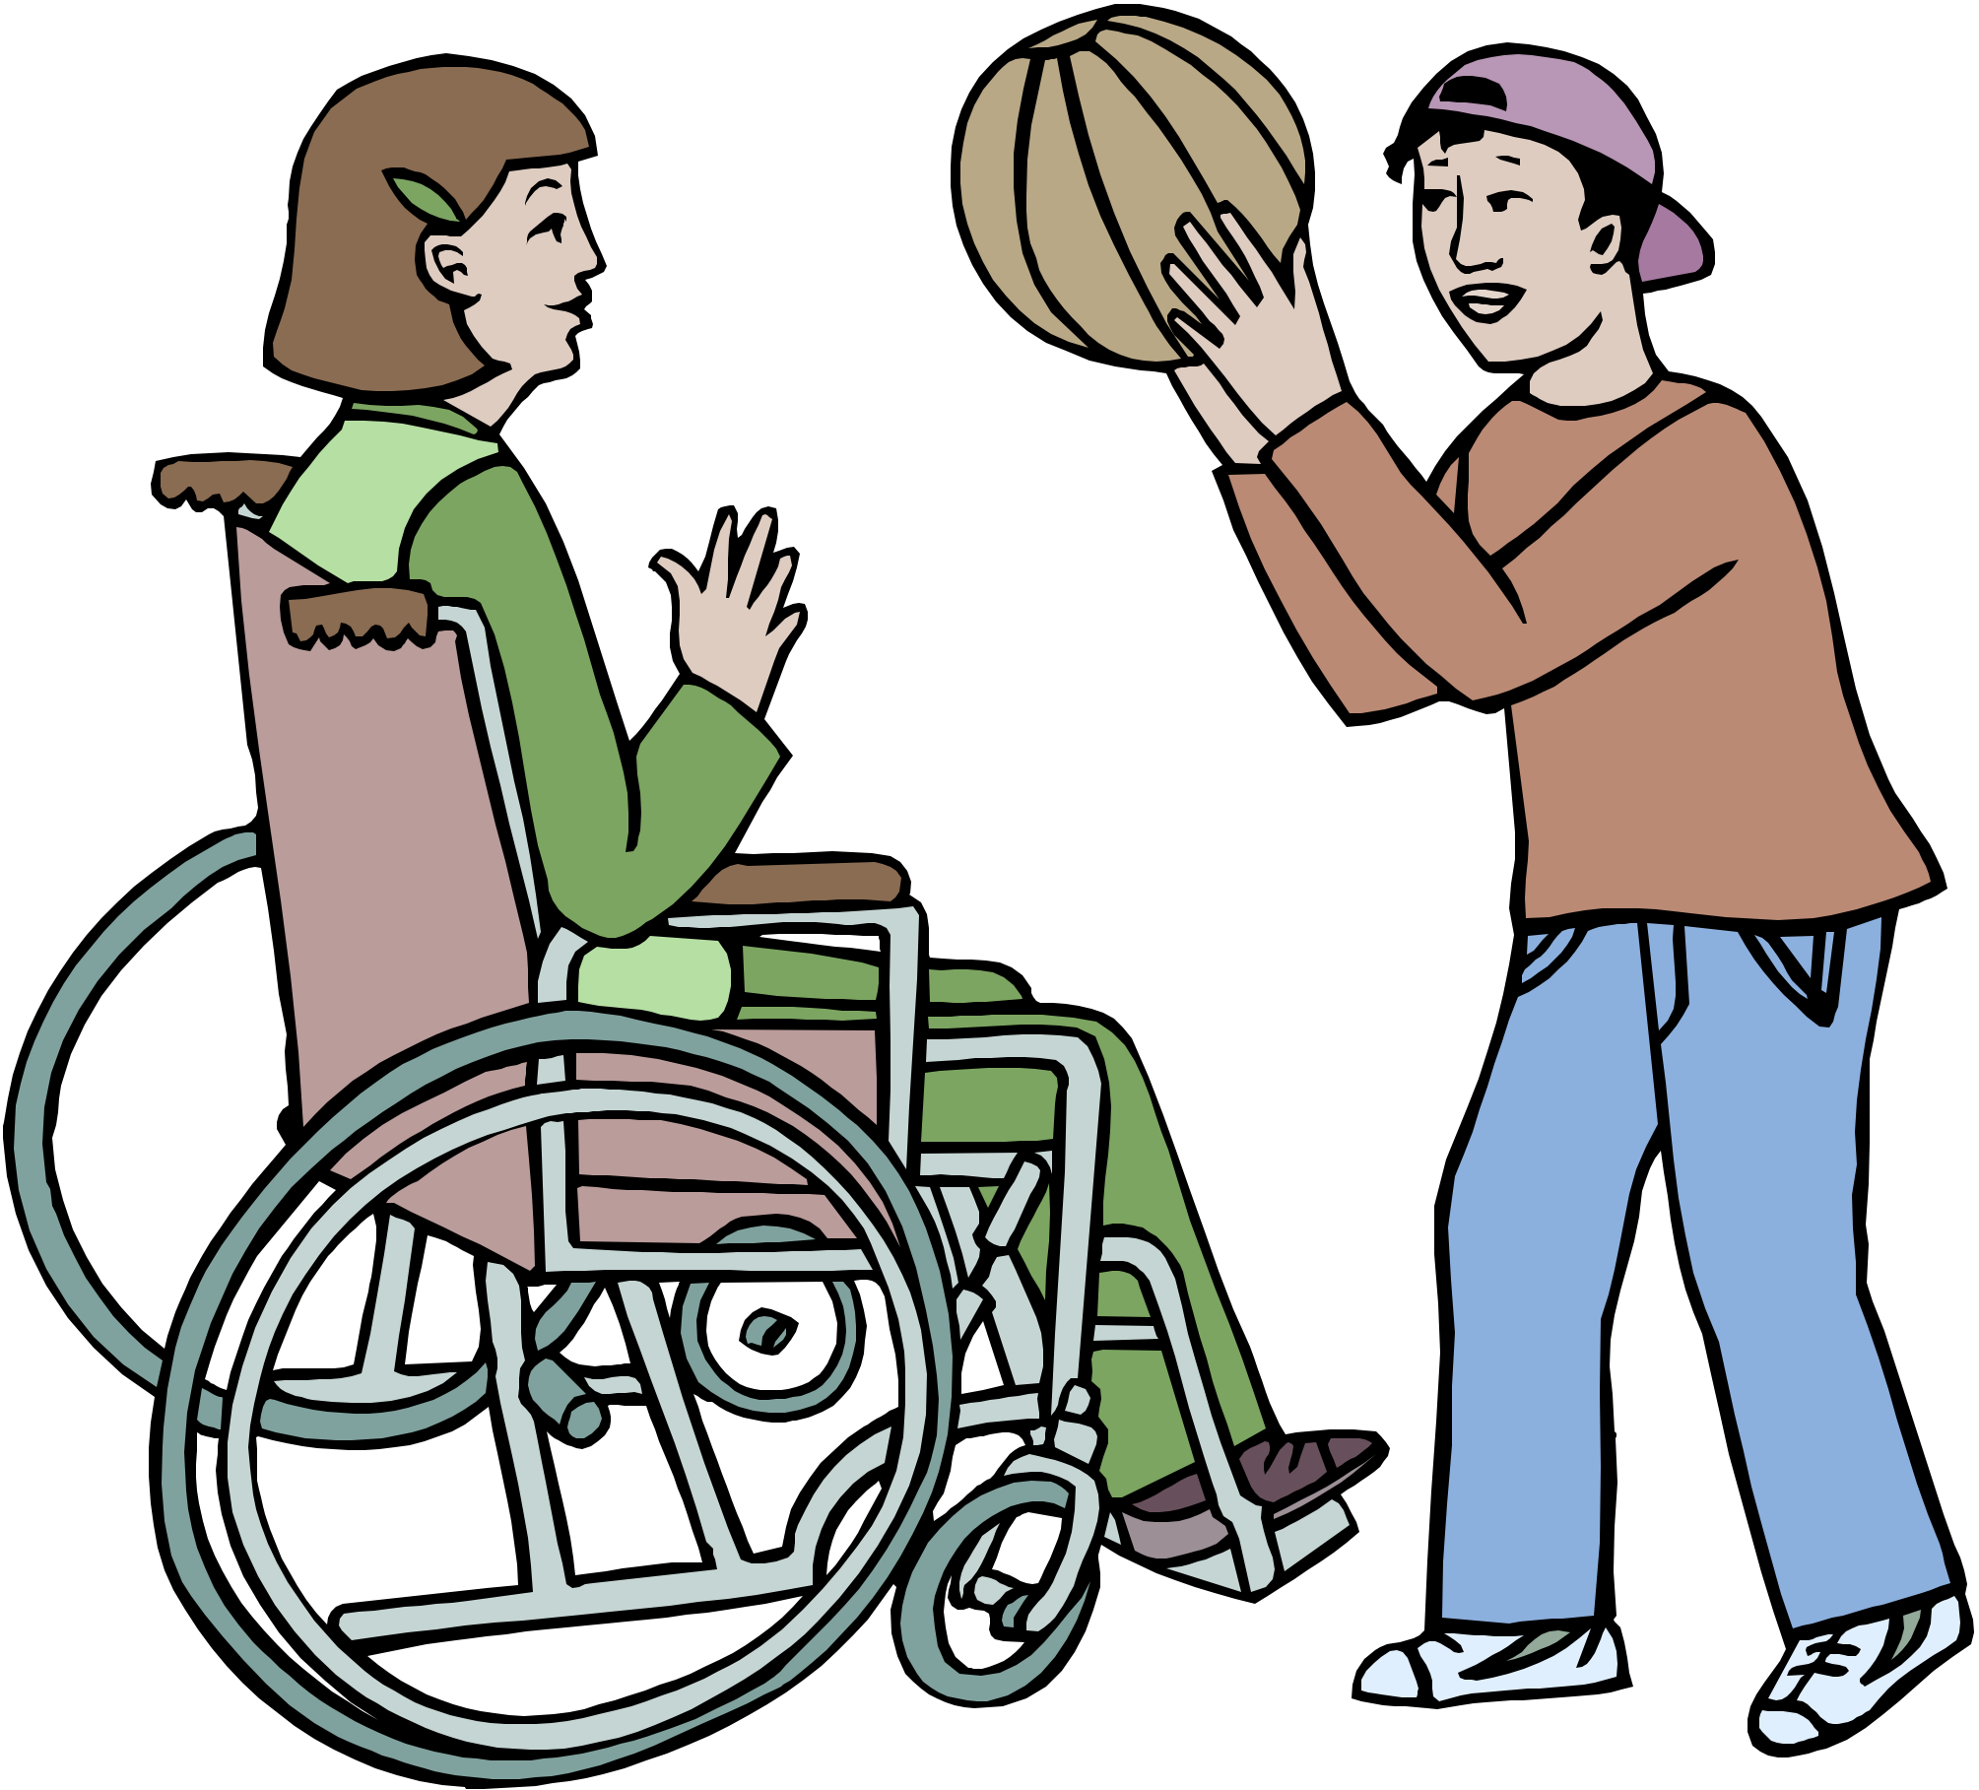

Health and Physical Education

Discover Adaptations for Physical Education

Revised and Edited 5/16/12 by

Anne Hill, BS/MEd
Susan Hooper, BA/MAEd
Marlene Reineke, BA/MEd
Barbara Schnizlein, BS/MEd

Under the auspices of
The Saint Paul Public Schools DAPE Department

All committee members are Licensed Physical Education and
Developmental Adaptive Physical Education Educators
IMPORTANT INFORMATION

- STUDENT SAFETY comes FIRST.

- Know the health condition of EVERY student in
EVERY class.

- Check health files for student conditions that may
require adaptations or modifications to your
physical education activities.

- REMEMBER! Some handicapping conditions are
hidden and not obvious.

- The adaptations provided in this document are only
sampling or options for your use.

- Be creative and come up with your own
adaptations!

Developmental Adaptive Physical Education Adaptations
Table of Contents

Activity Page
Aerobic Dance …………………………………. 1
Archery ………………………………………… 2
Badminton ……………………………………… 3
Basketball ……………………………………… 4
Bowling ………………………………………… 5
Circuit Training …………………........................ 6
Fitness Testing ………………………………….. 7
Floor Hockey, Ringette, Broomball ……………. 8
Football …………………………………………. 9
Golf ……………………………………………... 10
Group Tasks ……………………………………. 11
Gymnastics/Tumbling/Apparatus ……………… 12
Jump Rope ……………………………………… 13
Manipulatives …………………………………… 14
Racquet Sports ………………………………….. 15
Recreational Games …………………………….. 16
Rhythms and Dance …………………………….. 17
Soccer …………………………………………… 18
Social Dance ……………………………………. 19
Softball/T-Ball ………………………………….. 20
Speedball ……………………………………….. 21
Strength Training ……………………………….. 22
Swimming ………………………………………. 23
Team Handball ………………………………….. 24
Track and Field …………………………………. 25
Ultimate Frisbee ………………………………… 26
Volleyball ……………………………………….. 27
Weight Training ………………………………… 28
Winter Activities ………………………………... 29

AEROBIC DANCE

PHYSICALLY OR HEALTH IMPAIRED
1. A student with limited movement/ a balance problem, can perform in any type of chair
2. Use of upper body motion only if student has no lower body movement
3. Use of upper body and as much leg movement/ trunk rotation as possible
4. Stabilize the wheel chair/belt the student in if movements may cause loss of balance
5. Remove the foot rests of the wheel chair for a larger space to move the legs
6. Move other body parts/equipment instead of leader directed body part
7. Slow down the tempo of the music or do at half speed
8. Student performs only half of the counts, i.e. slow motion 4 counts to an 8 count move
9. Replace foot movements with hand movements
10. Students perform their own creatively learned aerobic routine to any routine taught
11. Place the student in an ample/unrestricted space
12. Teach the student an alternative movement pattern if the pattern is too complicated
13. Teach the class to do a routine with everyone in some type of chair
14. Student has the option of exercising on the floor.

SENSORY IMPAIRED
1. Use blinking lights to indicate the beat of the music
2. A sighted partner may be used for a guide, maintaining close contact
3. Give precise verbal instructions
4. Place students in a position to prevent contact with other dancers
5. Use the low bass sound
6. Keep students close to the music speakers and to the instructor
7. Use specific hand signals and arrows when indicating specific steps and direction
8. Have everyone clap the beat before starting the routine
9. Guide by placing a hand on a shoulder or by holding hands
10. Mark the dance area or step with bright colored/contrasting colored tape

LEARNING OR MENTALLY IMPAIRED
1. Repeat demonstrations and directions often
2. Use mirrors to let students see how the routine looks as they perform
3. Give the student a specific space to in which to perform
4. Give them an alternative movement pattern if the pattern is too complicated
5. Student performs only half of the counts, i.e. slow motion 4 counts to an 8 count move
6. Students perform their own creatively learned aerobic routine to any routine taught
ARCHERY

PHYSICALLY OR HEALTH IMPARED
1. Use any type of chair to practice shooting
2. Angle the chair to allow space for the bow to hang freely
3. Remove arm rests of the wheel chair if it will allow more freedom
4. Pair the student with a partner
5. Partner can retrieve arrows and bring them back to the arrow quiver
6. Partner can assist with calling scores back to the student
7. Stabilize the chair
8. Secure the bow to the wall/post/wheel chair if the student has use of only one arm
9. Stand behind the student to help steady the bow and to teach the proper arrow release
10. Provide light bows for students that have limited strength
11. Use an indoor teaching facility

SENSORY IMPAIRED
1. Use a bright light/visual hand cue/tap on the shoulder to signal start of shooting round
2. Pair the student with a partner
3. Have partner place them in correct stance/arm position for accurate aiming direction
4. Send them out with their partner to retrieve arrows
5. Partner can assist with calling scores back to the student
6. Reduce unnecessary noise so student can gain more auditory cues
7, Use neon or bright colored targets and arrows
8. Use neon or bright colored line to shoot behind
9. Put a bright light or beeper on the target
10. Demonstrate facing student

LEARNING OR MENTALLY IMPAIRED
1. Emphasize safely
2. Pair with partner to reinforce detail in the skill and to repeat the safely rules
3. Give double cues
4. Allow a partner to help with scoring
5. Be specific on the task required when the student is not shooting
6. Have the student sit down when s/he is not shooting
7. Unobtrusively mark right/left limbs for students who are confused about right/left
8. Give frequent reminders of the sequence in the activity to aid in establishing a routine

BADMINTON

PHYSICALLY OR HEALTH IMPAIRED
1. Use shorter, lighter racquets
2. Secure the racquet to hand and /or arm with tape
3. Have partner drop the ball or bird
4. Use Nerf balls, balloons, beach balls, wiffle balls, or fleece balls
5. Allow two or more bounces if using a ball
6. Allow more than one serve attempt
7. Decrease height of net
8. Increase the number of players on the team of the student with a disability
9. Decrease distance of service
10. Modify court size
11. Play doubles
12. Have everyone play from a sitting position
13. If ball or bird hits chair, continue play from that spot with a hit or throw
14. Allow individual to throw/catch object instead of using a racquet

SENSORY IMPAIRED
1. Use neon or bright colored balls, birdies or balloons with bells inside
2. Use very large face racquet with short handle
3. Student with visual impairment may take part as server
4. Increase number of players in the game
5. Pair with a partner
6. Demonstrate skills facing student
7. Consider if this activity is really in the future of the student

LEARNING OR MENTALLY IMPAIRED
1. Allow larger faced racquet.
2. Use balloons and Nerf balls
3. Simplify the rules
4. Let overhand hits be accepted on the serve
5. Pair with a partner
6. Play with a large group and score as in volleyball
7. Provide clear verbal instructions and demonstrations
8. Give manual guidance if needed
BASKETBALL

PHYSICALLY OR HEALTH IMPAIRED
1. Student in wheelchair may dribble once then place ball in lap and wheel three times
2. Use lighter weight ball and or a smaller ball
3. Wear protective head gear
4. Slow the pace of the activity and modify the intensity
5. Lower the baskets and/or throw at a larger hoop, i.e., a hula hoop vertical/horizontal
6. Reduce court size
7. Pair the student with a partner
8. Give student an unguarded shot if they receive a pass
9. If ball hits the chair or touches hand, it becomes their possession
10. More points for basket made
11. Points for hitting rim or backboard
12. Ghost player to help receive passes (not allowed to score, etc.)
13. All players must walk during the game
14. Allow player to hold the ball longer, travel and double dribble
15. Add one extra player to the team of the student with impairment
16. Allow extra distance between the student in a wheel chair and defense

SENSORY IMPAIRED
1. Demonstrate all drills so students can see
2. Face the student when teaching
3. Write out rules so student can read them before or during class
4. Pair the student with a partner
5. Ghost player to help receive passes
6. Hand them the ball rather than pass it
7. Beeper or bell in ball
8. Beeper or bell behind the target basket
9. Bright light or contrasting colors on or near basket
10. Change the color of the ball example: yellow or black

LEARNING OR MENTALLY IMPAIRED
1. Repeat drills and pre-teach skills
2. Have fewer students play at a time
3. Use cones for boundaries
5. Reduce rules and provide multiple cues
BOWLING

PHYSICALLY OR HEALTH IMPAIRED
1. Instead of using finger holes, use a bowling ball with retractable release handle
2. Provide a bowling ramp for students who cannot roll the ball at their side
3. Provide a bowling cue stick or push stick to push a ball down the alley
4. Place the bowler at the foul line and use no approach steps if movement is difficult
5. Remove arm rests from wheel chair if the disability will allow
6. Have a partner get their bowling ball for them
7. The student may keep score if activity is not possible
8. Experiment with both left and right hands
9. Have the bumpers placed in the alley gutters

SENSORY IMPAIRED
1. Pair with a partner to place them in correct stance for direction
2. Have partner give the ball to the student who is visually impaired
3. Use neon pins or tape on pin to enhance contrast of color
4. Tell the student who is visually impaired how many pins they knocked down
5. Use a cone to mark the point of beginning approach
6. Diagram the alley markings for the student who is hearing impaired
7. Demonstrate clearly how to position the body to pick up specific spares
8. Teach the pendulum swing to the student who is visually impaired
9. Add a beeper in pins or light behind pins
10. Allow student to use a ramp

LEARNING OR MENTALLY IMPAIRED
1. Use bumpers in the gutters
2. Teach the delivery of the ball in an area away from the alley
3. Break down the delivery and focus on one part at a time
4. Demonstrate the part of the technique you are teaching
5. Reinforce skill performance immediately
6. Teach the one, two, three, four, or five step approaches
7. Place student at the foul line and use no approach steps
8. Use various methods for knocking pins down, regardless of how the skill looks
9. Give manual assistance when needed -
10. Use peers as teachers and as models
11. Allow them to score by recording the number of pins knocked down
CIRCUIT TRAINING

PHYSICALLY OR HEALTH IMPAIRED
- Students can perform activities in their chair or transfer to a bench if weight lifting
2. Students with canes and crutches will be able to do upper body activities sitting down
3. Pair the student with a partner that can assist them
4. Substitute another activity when the original one is not physically possible or is unsafe
5. Activities that can be substituted are: stretching, juggling, weights, Dina bands, rowing
machine exercise, hanging on rope, throwing ball at wall and self-hitting a ping ball
6. Use a line on the floor to do such moves as: wheel forward/backward/turn left/turn right
7. An activity can be repeated at another station
8. Student may select stations that do not require equipment and repeat the movements
9. Make sure the student has completed an adequate warm up routine
10. Have the student perform only half of the required time - i.e. 15 seconds instead of 30
11. The student can be creative and invent his or her own station activity

SENSORY IMPAIRED
1. Have a partner to guide them through activities and help record their results
2. Allow the student to explore each piece of equipment with tactile exploration
3. Allow extra space when jumping rope, as students may jump sideways
4. Substitute an alternate activity if safely is a problem
5. Demonstrate everything so students can see clearly
6. Balance may be a problem for the students who is visually impaired

LEARNING OR MENTALLY IMPAIRED
1. Provide a high functioning partner to pair with the student
2. Allow extra time for the student to understand how to do the activity at each station
3. Demonstrate clearly what is to be done at each station
4. Give the student an alternative movement if the skill is too complicate
5. Help students find the correct station to start at each day and how to follow the sequential order from one day to the next
6. Allow extra time for student record keeping
FITNESS TESTING

PHYSICALLY OR HEALTH IMPAIRED
1. Decrease the distance and/or time required
2. Have student walk, jog, or wheel
3. Place blocks in hands of a standing student for the shuttle run
4. Have student knock down bowling pins at each line for shuttle run
5. Angle chair for throwing activities to allow cross body motion
6. Walk, wheel, or run independently for personal challenge
7. Two-foot jumping can be adapted to hand jumping where students start in a kneeling position. They then lunge with hands to see how far they can reach on the mat without allowing the trunk to touch
8. Do knee to chest lifts if curl-ups are not possible
9. Use wheel chairs on parking lots or tennis courts instead of grass
10. Substitute flexed-arm hang for pull-ups if student is medically fragile.
11. Lift student to the bar with at least two people if student can not stand independently and reach

SENSORY IMPAIRED
1. Use sighted partner for assistance
2. Use neon or bright colored blocks for shuttle
3. Use visual signal to start timed activities
4. Use guide wires for running or walking activities

LEARNING OR MENTALLY IMPAIRED
1. Decrease the distance
2. Pair the student with a partner
3. Demonstrate and cue more than once
4. Have a partner listen for time as student crosses finish line

FLOOR HOCKEY, RINGETTE, BROOMBALL

PHYSICALLY OR HEALTH IMPAIRED
1. Allow student to play a defense or goalie position
2. The wheel chair or walker may be used to block the puck, ring or ball
3. Classmates are not allowed within five feet of a player in a wheel chair
4 Allow a ghost player to help in any position
5. Feet, canes and crutches are allowed to block or propel the puck
6. Reduce the size of the playing area and/or limit playing time
7. All players must walk during the game
8. Restrict player to a definite place or position
9. Give more points for a goal scored and allow scores if it hits goal post or cone
10. Increase the number of players on the team with the student who is impaired
11. Use a small soft Nerf ball, yarn ball or styro puck instead of a hard puck
12. If ball/puck hits body/chair/cane a free unguarded shot/possession of puck may be given
13. Allow staff to push the wheel chair
14. Position the student near the goal of the offensive team to wait for a pass
15. Attach the stick to wheelchair or walker

SENSORY IMPAIRED
1. Use Nerf ball with neon/bright color (or the color that the student can see) for puck
2. Use a beeper ball or ball with a bell inside
3. Use a ghost partner for assistance
4. Demonstrate all drills so students who are impaired can clearly see them
5. Place students close to the demonstrator
6. Set up signs and signals for special calls

LEARNING OR MENTALLY IMPAIRED
1. Provide clear verbal instructions, demonstrate everything and check for understanding
2. Allow a free unguarded shot/pass if students’ stick touches the puck
3. Give the student extra skill instruction/practice
4. Provide the student with a specific zone to play in
5. Provide frequent feedback

IF PLAYED ON ICE
1. Consider whether student is safe on ice
2. Use a sled with straps and/ or crampons on the bottom of shoes/boots
3. Wear a helmet with a face mask
FOOTBALL

PHYSICALLY OR HEALTH IMPAIRED
1 Use a Nerf football or smaller/lighter equipment
2. Limit students playing time
3 Decrease the area of the field
4. Angle students chair when throwing to compensate for limited trunk rotation
5. Limit the distances to be thrown
6 Allow one bounce for a complete pass
7. Give the student a five count before they can be tagged when attempting a pass
8. Have a ghost partner assist in catching
9. Hike the ball from chair verses the ground
10. Ball may be placed in lap of the student in the wheel chair and given a five count to move before other team is able to make a play
11. All players must walk during the game
12. Add a student to the team of the student who is physically impaired
13. Wear protective head gear
14. If ball hits the student’s chair or hand, the ball is in his/her possession

SENSORY IMPAIRED
1. Use bright colored equipment or with auditory cues (beeper, bells, etc.)
2. Use bright colored area markers
3. Limit the playing area
4. Provide a ghost partner to catch the ball and hand it to the student to throw
5. Give assistance at the elbow while student is running with the ball
6. Have partner repeat the verbal directions

LEARNING OR MENTALLY IMPAIRED
1. Use ample demonstrations
2. Simplify the rules and limit them to only a few
3. Repeat the important rules several times and review daily
4. Remove all distractions that would interfere with watching demonstrations
6. Give manual assistance
7. Allow a partner to assist
8. Keep competition to a minimum
9: Play Ultimate Football
GOLF

PHYSICALLY OR HEALTH IMPAIRED
1. Use alternate hitting device such as a hockey stick or piece of PVC tubing
2. Lengthen or shorten the club to accommodate the student in a wheel chair
3. Hit into hula hoops, large bucket or onto a large mat
4. Use any type of chair to practice the skill
5. Use only one hand or arm for swinging club or putting
6. Experiment with both left and right handed clubs
7. Use suction cup on end of club or putter to pick up the ball
8. Shorten the length of the hole
9. Substitute Frisbee golf

SENSORY IMPAIRED
1. Use bright colored or neon ball
2. Pair with partner to place them in correct stance for direction to hit the ball
3. Pair with partner to spot distance
4. When demonstrating face the student
5. Use neon or bright colored targets
6. Hit from behind a bright colored or neon line

LEARNING OR MENTALLY IMPAIRED
1. Emphasize safety
2. Pair with partner to reinforce detail in the skill and to repeat the safety rules
3. Give double cues
4. When the student is not hitting have them sit down
5. Mark right and left limbs for students who are confused about right and left
6. Give frequent reminders of the sequence in the activity to aid in establishing a routine
GROUP TASKS

PHYSICALLY OR HEALTH IMPAIRED
1. Be aware of student’s impairment as it would affect safe participation
2. Modify activity to allow the group a rule change at any time
3. Place student in a safe working position where there is no risk of losing balance or injury
4. Allow student to only give verbal support
5. Alter size of equipment as needed

SENSORY IMPAIRED
1. Reduce unnecessary noise .
2. Use bright colored task objects
3. Use larger objects for the tasks
4. Participate in activities indoors if possible to reduce extraneous noise
5. Use auditory and visual cues (signs, arrows, large letters, flags, lights, and picture schedules)
6. Place student where s/he can gain the most visual cues
7. Use noisemakers (bells, cans, whistles) to indicate success and/or mistakes
8. Demonstrate the task objective
9. Use guide ropes with knots to indicate distance to move
10. May pair up with a partner

LEARNING OR MENTALLY IMPAIRED
1. Explain objective of the task slowly and clearly
2. Simplify rules, go over them one at a time, and repeat them if necessary
3. Give a specific task role to the student
4. Use short, clear statements when giving instructions
5. Students may have a reduced attention span
6. Have the student sit in a specific spot during transitions
7. Use cones/markers to delineate boundaries of tasks
8. Mark right and left limbs of students who are confused about right and left

GYMNASTICS/ TUMBLING/APPARATUS

PHYSICALLY OR HEALTH IMPAIRED
1. Make sure the student has completed an adequate warm up routine
2. Students may need the aid of a spotter
3. Students in wheel chairs may use the skills of: front support, walking the bars, turning, and leg swinging on the horse or even parallel bars
4. Instead of vaulting the horse, students may spring on the board, do front and rear supports, sit, stand, and do V-seats on the horse
5. A low balance beam/line on the floor may be used to perform walking/turning moves
6. Students may use a line on the floor to do a balance beam routine with such moves as: wheel forward, backward, turn left/turn right
7. Reduce the requirements for a student by allowing them to select one or two pieces of
equipment and perfecting one, two, or three simple skills
8. Students that have good use of their upper bodies can transfer out of their chair and
perform some activities using upper body only
9. A tumbling skill could be substituted for a skill on a piece of equipment
10. Require one or two repetitions moving down a tumbling mat instead of tumbling the entire length of the mat
11. Substitute physical fitness activities for apparatus and tumbling skills, such as: stretching activities, cardio programs and/or strengthening programs
12. Equipment can be modified (raise or lower height)

SENSORY IMPAIRED
1. Students may need a partner to guide him or her through the activities
2. Allow the students to explore each piece of apparatus with his/her hands
3. Balance may be a big concern
4. Apparatus pieces may be unsafe for students who are visually impaired and may not include skills that they will need to carry over for lifetime activities
5. Allow students extra mat space when tumbling
6. Demonstrate everything so that students who are hearing impaired can see clearly

LEARNING OR MENTALLY IMPAIRED
1. Provide a partner to follow the student through all stations of activities
2. Allow alternative movement patterns if the routine is too complicated
3. Give credit for the skill being attempted or part of skill mastered

JUMP ROPE

PHYSICALLY OR HEALTH IMPAIRED
1. Student may turn the rope for long rope jumping
2. A partner can help the student who is impaired turn the rope
3. Attach rope to students’ hand by using Velcro to assist in rope turning
4. Stepping over the rope instead of jumping can be done on the forward/backward jump
5. Lay the rope on the floor and jump or just step over it
6. Jump or step over a line on the floor
7. Swing the rope on just one side of the body while jumping in place or just marching
8. Tie one end of rope to a fixed object so that the student can practice rope turning
9. Students who are unable to jump may verbally recognize different jump roping skills

SENSORY IMPAIRED
1. Have a partner tell the student who is visually impaired when to jump
2. Put a bell on the rope
3. Listen for the rope as it hits the floor
4. The long rope partner jumps with the student (holding hands) so s/he knows
when to jump
5. Allow student to select the best color of rope
6. Demonstrate clearly for the hearing impaired

LEARNING OR MENTALLY IMPAIRED
1 Stepping over the rope instead of jumping can be done on the forward/backward jump
2. Lay the rope on the floor and jump or step over it
3. Demonstrate as often as needed
4 Allow extra practice time as needed
5. Turn the rope and have them step over it
6. Have student stand next to the long rope rather than running in
MANIPULATIVES

PHYSICALLY OR HEALTH IMPAIRED
1. Transfer students in wheel chairs to the floor when appropriate
2. Pair with a partner
3. Attach items to students’ hands or wheel chairs when appropriate, i.e. Velcro/tape
4. Put items on a string or rope so that the equipment comes back
5. A partner may assist in getting equipment to the floor or to assist in catching
6. Sit students in a chair/lean against a wall for balance/support using a belt if necessary
7. Shorten distance if movement is required
8. Stay at one level of body position for a period of time instead of moving up/down
9. Consider altering/modifying for each student’s individual needs

SENSORY IMPAIRED
1. Use student’s preferred colored objects i.e. contrasting colors
2. Use a variety of textured items
3. Place the student close to the teacher to clearly see the demonstration
4. Pair with a partner to help with object control
5. Use signing for starting and stopping

LEARNING OR MENTALLY IMPAIRED
1. Pair with a partner
2. Demonstrate more than once
3. Break skills down to the basics, i.e. Task Analysis
4. Provide manual assistance when necessary

RACQUET SPORTS

PHYSICALLY OR HEALTH IMPAIRED
1. Use shorter and lighter racquets
2. Secure the racquet to hand and /or arm with Velcro
3. Have partner drop the ball
4. Pair with partner for backboard practice
5. Use Nerf balls, balloons, beach balls, wiffle balls, fleece balls or low-flight tennis balls
6. Allow two or more bounces if using any kind of ball that bounces
7. Allow extra serve attempts
8. Allow the serve to come from a bounce
9. Allow the serve to be taken from anywhere inside the court boundaries
10. Allow the serve to land anywhere inside the court boundaries
11. Decrease height of net and/or modify court size
12. Increase the number of players on the team of the student who is impaired
13. Decrease distance of service
14. Play doubles
15. Have everyone play from sitting position
16. If the ball hits the chair, continue play from that spot with a hit or serve
17. Provide the student with a court that is close to the building
18. Provide an extra person to chase balls
19. Teach cross handed wheeling

SENSORY IMPAIRED
1. Use neon, bright colored, low flight balls or balloons with bells inside
2. Use very large face racquet with short handle
3. Increase number of players in the game
4. Pair with a partner
5. Demonstrate skills facing student

LEARNING OR MENTALLY IMPAIRED
1. Allow larger faced racquet
2. Use balloons or modified balls
3. Let overhand hits be accepted on the serve and/or simplify the rules
4. Pair with a partner and/or give manual guidance
5. Play with a large group and score as in volleyball
6. Provide clear verbal instructions and demonstration
RECREATIONAL GAMES

PHYSICALLY OR HEALTH IMPAIRED
1. Use shorter, lighter racquets
2. Secure the racquet to hand and /or arm with tape
3. Have partner drop the ball or bird
4. Use Nerf balls, balloons, beach balls, wiffle balls, fleece balls or indoor horseshoes
5. Allow two or more bounces if using a ball
6. Allow more than one serve attempt
7. Decrease height of net
8. Increase number of players and play specific positions
9. Decrease distance of service
10. Modify court size and/or play doubles
11. Have everyone play from a sitting position
12. Put a student in a wheel chair on both teams
13. If ball, bird, or ring hits chair, continue play from that spot with a hit or throw
14. Allow individual to throw and catch the object instead of using a racquet
15. Student may move closer in shuffleboard/horseshoes when pushing/throwing object
16. In table tennis, use the mini table and provide help to retrieve balls
17. In table tennis, accept a serve of the ball hitting the table before the paddle
18. Attach ball to tether at a fixed point or on a zip line so that it comes back to the student

SENSORY IMPAIRED
1. Use neon or bright colored balls, birdies or balloons with bells inside
2. Use very larger faced racquet with short handle
3. Have the student who is visually impaired take part as the server
4. Increase the number of players in the game and/or pair with partner
5. Demonstrate skills facing student

LEARNING OR MENTALLY IMPAIRED
1. Allow larger faced racquet and/or use balloons and Nerf balls
3. Simplify the rules
4. Let overhand hits be accepted on the serve
5. Pair with a partner and/or play with a large group and score as in volleyball
7. Provide clear verbal instructions and demonstrations
8. Give manual guidance if needed
9. In table tennis, accept a serve of the ball hitting the table before it hits the paddle
RHYTHMS AND DANCE

PHYSICALLY OR HEALTH IMPAIRED
1. Staff members may push the student's wheel chair
2. A student with limited movement may be placed in a wheel chair
3. Staff may place their hand on a shoulder/chair if student's hands are needed for wheeling
4. Clap hands/move head/tap cane/crutches/move other body parts instead of moving feet
5. Slow down the tempo of the music or perform at half the speed
6. Student performs half of the counts, i.e. slow motion 4 counts to an 8 count move
7. Replace foot movements with hand movements
8. Sit in chair (any chair) and tap feet or march instead of moving
9. The student in a wheelchair moves forward and back instead of changing directions
10. Students perform their own creatively learned dance to any dance taught
11. Student is placed in a position that will not slow down his/her speed or others’ speed
12. Teach the student alternative movement patterns if the pattern is too complicated

SENSORY IMPAIRED
1. Use blinking lights to indicate beat of the music
2. A sighted partner may be used for a guide maintaining close contact
3. Give precise verbal instructions
4. Place students in a position where they will not dance into others
5. Use the low base sound
6. Keep students close to the music speakers and to the instructor
7. Use specific hand signals and arrows when indicating specific steps and direction
8. Have everyone clap to the beat before starting the dance
9. Placing a hand on a shoulder or holding hands to guide the student

LEARNING AND MENTALLY IMPAIRED
1. Pair with a partner who has good social and interpersonal skills
2. Begin with slow moves and increase speed gradually
3. Repeat demonstrations and directions several times
4. Use mirrors to let students see how the dance looks as they perform
5. Give the student a specific space in which to practice
6. Pre-teach the dances and have extra practice sessions
7. Make sure the student is paying attention and watching the demonstration
8. Mark right/left limbs for students who are confused with right and left
10. Give them alternative movement patterns if the pattern is too complicated

SOCCER

PHYSICALLY AND HEALTH IMPAIRED
1. Limit player to a definite place or position
2. The wheel chair or walker is used to block the ball
3 Allow a ghost player to help in any position
4. Canes and crutches are allowed to block or propel the bail
5. Place a classmate in a wheelchair during the skills or game activity
6. Wear protective head gear as needed
7. Reduce the field size
8. Limit playing time
9. All players must walk during the game
10. Give more points for a goal scored and allow score it if it hits goal post or cone
11. Increase/decrease the number of players on each team as needed
12. Use a Nerf soccer ball
13. If ball hits student's body/chair/cane, s/he may be given a free unguarded shot/pass
14. Only allow staff members to push the wheel chair
15. Play indoors or on a non-grass surface
16. Play on a field that is close to the school building if the activity is outside
17. Position the student near the end line of the offensive team and allow them to remain
offsides the entire game and wait for a pass

SENSORY IMPAIRED
1. Play the game inside
2. Use a Nerf soccer ball with a neon or bright color
3. Use a beeper ball or ball with a bell inside
4. Use partner for assistance
5. Wear protective head gear as needed

LEARNING AND MENTALLY IMPAIRED.
1. Allow a free unguarded kick/dribble if the student touches the ball with his or her foot
2. Provide the student with a specific zone to play in
3. Wear protective head gear as needed

SOCIAL DANCE

PHYSICALLY OR HEALTH IMPAIRED
1. Have students wheel their chairs independently
2. A staff member may push the student's wheel chair
3. A student with limited movement may be placed in a wheel chair
4. Partners may place their hand on shoulder/chair if student's hands are needed for wheeling
5. Clap hands/move head/tap cane/crutches/move other body parts instead of moving feet
6. Slow down the tempo of the music or perform at half the speed
7. Student performs half of the counts, i.e. slow motion 4 counts to an 8 count move
8. Replace foot movements for hand movements
9. Sit in chair (any chair) and tap feet or march instead of moving
10. Student in wheel chair moves forward and back instead of changing directions
11. Students performs their own creatively learned dance to any dance taught
12. Student is placed in a position that will not slow down his/her speed or others’ speed

SENSORY IMPAIRED
1. Use blinking lights to indicate beat of the music
2. Use a sighted partner for a guide maintaining close contact
3. Give precise verbal instructions
4. Place students in a position where they will not dance into others
5. Use the low base sound
6. Keep students close to the music speakers and to the instructor
7. Use specific hand signals/arrows when indicating specific steps/direction
8. Have everyone clap to the beat before starting the dance
9. Placing a hand on a shoulder or holding hands may guide the student

LEARNING OR MENTALLY IMPAIRED
1. Pair with a partner who has good social and interpersonal skills
2. Require learning only of the easy and short dances
3. Begin with slow moves and increase speed gradually
4. Repeat demonstrations and directions often
5. Use mirrors to let students see how the dance looks as they perform
6. Give the student a specific space in which to practice
7. Pre-teach the dances and have extra practice sessions
8. Make sure the student is paying attention and watching the demonstration
9. Mark right/left limbs for students who are confused with right and left
SOFTBALL/T-BALL

PHYSICALLY OR HEALTH IMPAIRED
1. Allow and/or require everyone to hit off a batting tee
2. Permit another player to run in place of the batter
3. Use a lighter bat, a shorter bat, a flat bat, a “fat” bat, a pillow polo stick or a plastic bat
4. Increase the ball size
5. Reduce the size of the diamond
6. Play indoors or on a non-grass surface
7. Provide a no strike out situation or after three strikes the ball goes on a ‘T’
8. Shorten all the base-lines
9. Place another base between home plate & 1st base & declare them safe if made it safely
10. Delay the time the ball gets to the base, i.e. ball must be thrown to three different players
before it is thrown to 1st base
11. Provide a ghost partner for the student who is impaired when his/her team is in the field
12. If a student in a wheel chair is playing a base position, the runner is out if the throw to
the base hits the chair
13. If a fielding student touches the ball on a fly catch attempt, the batter is out
14. If the batter cannot swing the bat, the pitcher will attempt to just hit the bat with the
ball and it will be considered a hit
15. Allow for pitch hitter if necessary
16. Play on a field that is close to the building if the activity is outside
17. Hang ball from string so student can hit it, it will fly forward & come back to be hit again

SENSORY IMPAIRED
1. Use a beeper ball or a neon bright colored ball
2. Allow the use of a tee and/or increase the ball size
3. Provide a ghost-partner for assistance (by voice or touch)
4. Have a base coach call out their name continuously as they run to the base
5. Produce a type of loud sound coming from the base to which they are running
6. Use as many demonstrations as necessary for the hearing impaired
7. Provide visual signs for foul balls and outs if the student is hearing impaired

LEARNING AND MENTALLY IMPAIRED
1. Allow everyone to use a batting tee
2. Use a lighter bat, a shorter bat, a flat bat, a “fat” bat, a pillow polo stick or a plastic bat
3. Use a softer and/or larger ball
4. Pair with a partner when their team is in the field
SPEEDBALL

PHYSICALLY AND HEALTH IMPAIRED
1. Option to play a position that best suits their skills/abilities
2. The wheel chair or walker is used to block the ball
3 Allow a ghost player to help in any position
4. Canes and crutches are allowed to block or propel the ball
5. Allow game to be played inside
6. Wear protective head gear
7. Reduce the field size
8. Limit playing time
9. All players must walk during the game
10. Allow score if it hits goal post or cone
11. Increase the number of players on the team of the student with a disability
12. Use a Nerf soccer ball
13. If ball hits student's body/chair/cane s/he may be given a free unguarded pass/shot on goal
14. Allow the student in a wheel chair to pick the ball up at any time
15. The student may have a turn to officiate
16. Allow a staff member to push the wheel chair
17. Play on a field that is close to the building if the activity is outside
18. When the student is playing offensive allow them to remain offside and wait for a pass

SENSORY IMPAIRED
1. Play the game inside
2. Use a Nerf soccer ball with a neon or bright color
3. Use a beeper ball or ball with a bell inside
4. Use partner for assistance
5. Demonstrate all drills so students can clearly see them
6. Always face the students when instructing
7. Set up signs and signals for special calls

LEARNING OR MENTALLY IMPAIRED.
1. Provide clear verbal instructions for comprehension and demonstrate everything
2. Allow a free unguarded kick/pass if the student touches the ball with foot/hand
3. Give the student extra skill instruction and practice time
4. Provide the student with a specific zone to play in
5. To avoid confusion do not switch direction of play (ex. Half-time)
STRENGTH TRAINING

PHYSICALLY AND HEALTH IMPAIRED
- Use light weights, surgical tubing, dyna bands, rubber bands, bicycle tubes, soup cans,
towels or pulling plastic grocery bags through the air
2. Allow for extra time to move from one station to another
3. Pair the student with a partner, especially for spotting
4. Transfer student in a wheel chair to bench or chair if student is able to be moved
5. Belt/Velcro the student to the bench or chair for safety
6. Velcro wrist or ankle weights may be used for students with limited movement
7. Isometric exercises using teacher, partner or self resistance
8. Use of balls by squeezing to produce isometric resistance
9. Use only the student's body weight when doing full range of motion exercises
10. Option to do weight training in a swimming pool

SENSORY IMPAIRED
1. Use a sighted partner for a partner to spot and assist with equipment
2. Establish a pattern for using stations
3. Instruct the student on the stationary equipment how to check poundage by feel
4. Familiarize the student with the shape and feel of the dumb bell weights

LEARNING AND MENTALLY IMPAIRED
1. Demonstrate more than once and break down the technique into small parts
2. Place the student directly in front of the demonstration
3. Use a workout sheet to chart activity and establish a pattern of routine
4. Stress safety and proper range of motion when lifting
5. Pair with a partner who does not have a disability
6. Use mirrors to allow students to see how their movements look

SWIMMING

PHYSICALLY AND HEALTH IMPAIRED
1. Minimize the danger of slippery decks by transporting non-ambulatory students from
locker room to pool in a wheel chair
2. Students prone to seizures should wear a flotation device for safety
3. Use many different types of personal flotation devices
4. Pair students with a partner
5. Perform range of motion exercises
6. As a substitute for a swimming stroke the student may walk in the water
7. Tie a rope at both ends of the pool and have students pull themselves across
8. Shorten the distance and/or time of the required laps
9. Be aware that cold water may affect students of limited movement
10. Allow a medically fragile student to wear a T-shirt in the water
11. Use instruction aids such as kick boards, tubes, hand paddles, noodles, fins, goggles etc.
12. Adapt swimming strokes to meet student’s physical abilities
13. Rope off a section in the shallow end that will allow students with special needs to have an
area to work with a partner
14. Avoid long periods of inactivity in the water

SENSORY IMPAIRED
1. Have students swim with a partner
2. Students with visual impairments could be tapped on the shoulder when close to the edge
3. Use specific sounds, bells, or whistles for signaling to the visually impaired
4. Allow the students to swim with goggles
5. Use many visual cues for the hearing impaired
6. Use large colored spots at the end in the pool for students to use as a gauge

LEARNING AND MENTALLY IMPAIRED
1. Go very slowly with demonstrations and skill instruction
2. Use many water adjustment techniques and keep it age appropriate
3. Keep explanations simple
4. Pair student with a partner
5. Repeat skills and practice many times

TEAM HANDBALL

PHYSICALLY AND HEALTH IMPAIRED
1. Option to play a defense or goalie position
2. Allow student in wheel chair to play goalie along with a second goalie
3. Allow student in wheel chair to put the ball in his lap & wheel three times before throwing it
4. The wheel chair or walker/crutches/canes may be used to block the ball
5. Allow a ghost player to help in any position
6. Canes and crutches are allowed to block or propel the ball
7. Wear protective head gear
8. Reduce the field size and/or make the goal larger
9. Limit playing time
10. All players must walk during the game
11. Increase the number of players on the team of the student who is impaired
12. Use a Nerf soccer ball
13. If ball hits student's body/wheelchair/walker/crutch/cane s/he may be given a free
unguarded throw
14. The student may officiate
15. Allow a staff member to push the wheel chair
16. Play indoors or on a non-grass surface
17. Play on a field that is close to the school building if the activity is outside
18. Position the student near the throwing circle of the offensive team and allow them to remain
offside and wait for a pass

SENSORY IMPAIRED
1. Play the game inside
2. Use a Nerf ball with a neon, bright, student preferred color
3. Use a beeper ball or ball with a bell inside
4. Use partner for assistance
5. Demonstrate all drills so students can clearly see them
6. Always face the students when instructing
7. Set up signs and signals for special calls

LEARNING AND MENTALLY IMPAIRED.
1. Provide clear verbal instructions and demonstrate everything
2. Allow a free unguarded throw if the ball touches the student
3. Give the student extra skill instruction and practice
4. Provide the student with a specific zone to play in
TRACK AND FIELD

PHYSICALLY OR HEALTH IMPAIRED
1. Decrease the distance
2. Have student walk or wheel
3. Angle the chair for throwing activities to allow cross body motion
4. Walk, wheel, or run independently for personal challenge
5. Long jump - From a standing position lunges forward with one leg and measure
the distance between both feet. Use a classmate for hand balance
- Jumping - adapt to hand jumping. Student starts in kneeling position and then lunges with
hands to see how far s/he can reach on the mat/sand/grass without allowing torso to touch
8. Wheel on black top, parking lot, or tennis court instead of grass
9. Give the students with limited movement a distance advantage or "head start"

SENSORY IMPAIRED
1. Use sighted partner for assistance, especially around throwing objects
2. Provide a beeper at jumping event
3. Use visual cue or a flashing light to signal the start of timed events or activities
4. High jump or long jump from a stationary position
5. Use guide ropes for running or walking activities
6. A student with a visual impairment may need hands on guidance for throwing events
7. Use many visual cues and signing for the hearing impaired
8. Position student close to the instructor
9. Face the student when demonstrating

LEARNING OR MENTALLY IMPAIRED
1. Pair the student with a partner
2. Demonstrate and cue more than once
3. Have a partner listen for time as student crosses finish line
4. Allow partner help with measurements of throwing events
5. Allow as much instruction and practice as needed.

ULTIMATE FRISBEE

PHYSICALLY OR HEALTH IMPAIRED
1. Have the student play a position best suited for their skill level
2. The wheel chair, walker, crutches/cane can be used to block the Frisbee
3 Allow a ghost player to help in any position
4. Canes, crutches or other DAPE equipment are allowed to block or propel the Frisbee
5. Wear protective head gear
6. Reduce the field or court size
7. Limit playing time
8. All players must walk during the game
9. Allow score if Frisbee goes over the goal line and touches the student and/or equipment
10. Increase the number of players on the team of the impaired student
11 Use a soft Frisbee
12. If Frisbee hits student's body/chair/cane, s/he may be given a free unguarded throw
15. The student may officiate the game
16. Allow staff to push the wheel chair
17. Play indoors or on a non-grass surface
18. Play on a surface that is close to the school building if the activity is outside
19. Position the student near the end line of the offensive team and allow s/he to remain offsides
and wait for a pass

SENSORY IMPAIRED
- Attach bells to Frisbee & use one that is neon, bright colored or student-preferred color
- Use partner for assistance
- Demonstrate all drills so impaired student can clearly see them
- Always face the students when instructing
- Set up signs and signals for special calls
- Allow the student to start the first throw

LEARNING OR MENTALLY IMPAIRED
1. Provide clear verbal instructions and demonstrate everything
2. Allow a free unguarded throw if the Frisbee touches the student's hand, but is not caught
3. Give the student extra skill instruction and practice
4. Provide the student with a specific zone in which to play

VOLLEYBALL

PHYSICALLY OR HEALTH IMPAIRED
1. Use a neon/bright colored ball, trainer size ball, beeper ball, Nerf ball, balloon or beach ball
2. Modify the court size
3. Catch and throw the ball rather than strike the ball during play or on the serve
4. Have the student move closer to the net when serving
5. The student may play the ball off one or more bounces
6. If ball hits student/wheelchair/crutches/cane let student toss the ball/toss it up and strike it
7. The student may catch the ball or toss it up and strike it any time during the game
8. The student may hit the ball consecutively before hitting it to a teammate or across the net
9. Allow the student more than one serve attempt
10. Increase the number of players on the team of the student who is impaired
11. Decrease the height of the net
12. Allow extra hits per side before ball travels over the net
13. Ghost player may hold the ball for the server

SENSORY IMPAIRED
1. Use a neon/bright colored ball, trainer size ball, beeper ball, Nerf ball, balloon or beach ball
2. Have student take part as server and/or increase the number of players in the game
3. Ghost partner catches the ball, hands it to the student who may throw it over or strike it
4. Decrease the size of the court
5. Put neon or bright colored tape on the top of the net
6 Use many visual cues for the hearing impaired
7. Demonstrate all skills facing the student

LEARNING OR MENTALLY IMPAIRED
- Use a trainer ball, Nerf ball, beach ball, balloon, or two balloons inside each other
2. Provide clear verbal instructions and demonstrations, repeat as needed.
3. Have the students walk through the serving rotation several times
4. Allow the student to throw for a serve if necessary
5. Allow the student more than one serve attempt
6. Have the student move closer to the net when serving
7. Catch and throw the ball rather than strike the ball during play
8. The student may play the ball off one or more bounces
9. Increase the number of players on the team of the student who is impaired
10. Focus one or two key skills while playing a game
WEIGHT TRAINING

PHYSICALLY OR HEALTH IMPAIRED
- Use light weights, surgical tubing, dyna bands, rubber bands, bicycle tubes, towels, or
pulling plastic grocery bags through the air
2. Allow for extra time to move from one station to another
3. Pair the student with a partner, especially for spotting
4. Transfer student who uses a wheelchair to bench or chair if student is able
5. Belt the student to the bench or chair for safety
6. Velcro wrist or ankle weights may be used for students with limited movement
7. Isometric exercises using teacher, partner or self resistance
8. Use of balls by squeezing to produce isometric resistance
9. Use student's body weight only when doing full range of motion exercises
10. Use Velcro gloves/mitts for students that have poor grip strength

SENSORY IMPAIRED
1. Use a sighted partner to spot and assist with equipment
2. Establish a pattern for using stations
3. Instruct the student when using stationary equipment how to count the poundage by feel
4. Familiarize the student with the shape and feel of the dumb bell weights

LEARNING OR MENTALLY IMPAIRED
1. Demonstrate more than once and break down the technique into small parts
2. Place the student directly in front of the demonstration
3. Use a workout sheet to chart activity and establish a pattern of routine
4. Stress safety and proper range of motion when lifting
5. Pair with a partner who does not have a disability
6. Use mirrors to allow students to see how their movements look

WINTER ACTIVITIES

PHYSICALLY OR HEALTH IMPAIRED
1. Crutches or canes can be used instead of ski poles
2. Have teaching area close to building to allow for differences in speed/endurance of student
3. Pair with a classmate for assistance as needed (except pulling sleds)
4. Provide extra time for dressing to go outside
5. Option to attach skis to the bottom of a walker

SENSORY IMPAIRED
1. Pair with a classmate for assistance as needed
3. Student with a visual impairment may need hands-on guidance for learning proper technique
4. String guide ropes with knots to indicate distances when skiing or snowshoeing
5. Tether student who is visually impaired to partner to help them stay in desired path
6. Whistles may indicate success/direction of practice/alert the student to mistakes or obstacles
7. Use brightly colored cones or flags to delineate boundaries of a field or course
8. Face the student when demonstrating

LEARNING OR MENTALLY IMPAIRED
1. Pair with a classmate for assistance as needed
2. Use many demonstrations
3. Give assistance in fitting proper equipment
4. Provide help in putting equipment on during the first few days

SAFETY CONCERNS
1. Be aware of students that are sensitive to cold and have no sense of feeling
2. Communicate with parents when the activity is to be out-of-doors in winter
3. Carefully discuss the proper clothing to be worn outside
4. Do not allow students to be outside if, in your opinion, they do not have the proper clothing
5. The student in a wheel chair can be transferred to a sled and propel him or herself with
short hand poles or be pulled by a staff member
6. Make sure staff and students know how to check for frost bite

